**Practical No 4**

**Aim**: Create cube using SSAS(SQL Server Analysis Services.) and process

the cube.

**Solution:**

1. Right click on Cubes -> New Cube.

Click on

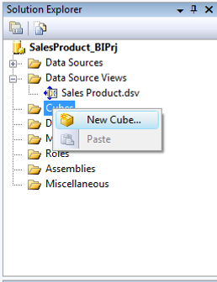

Click on Next.

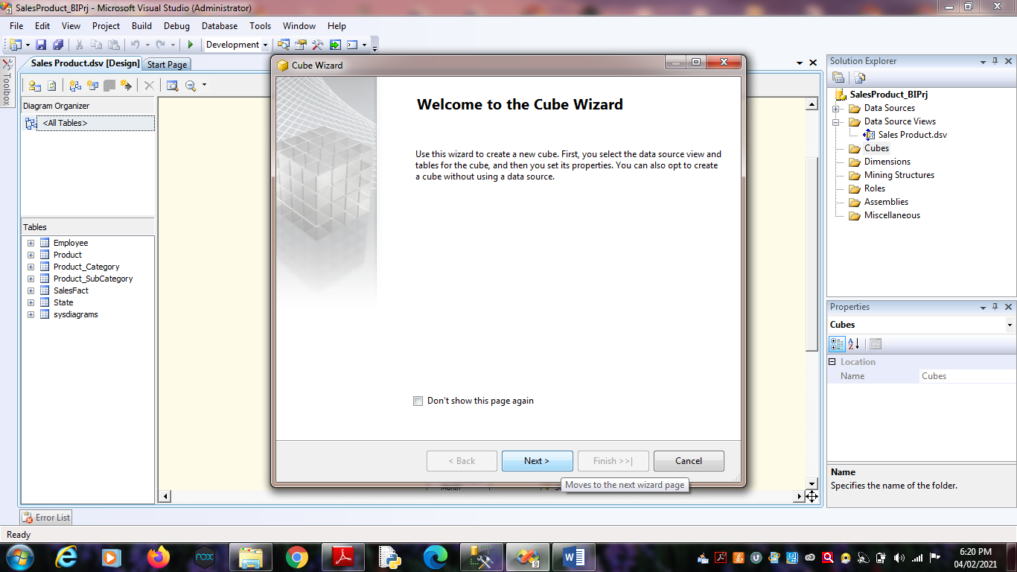

2. Select First option “Use existing tables”. Click on Next.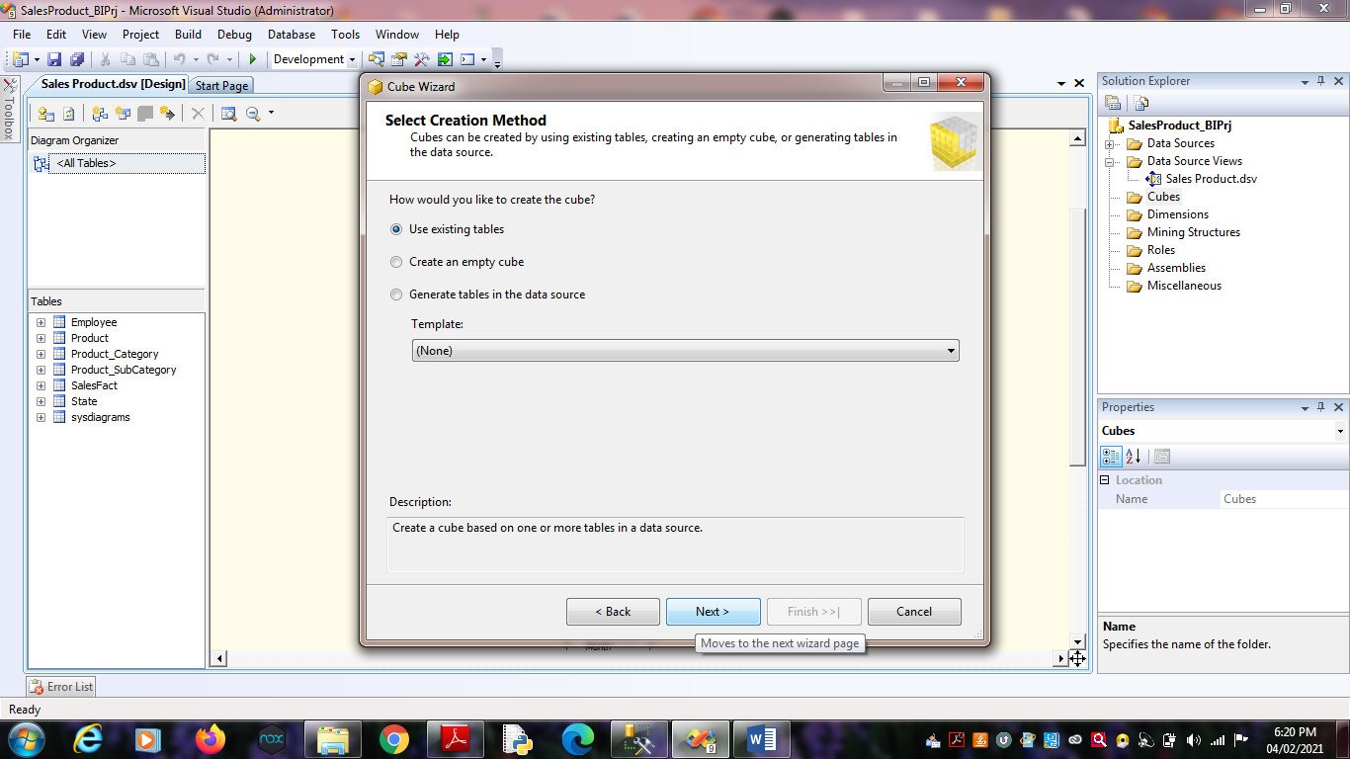

3. Select Data Source View as “Sales Product” and Select all the tables.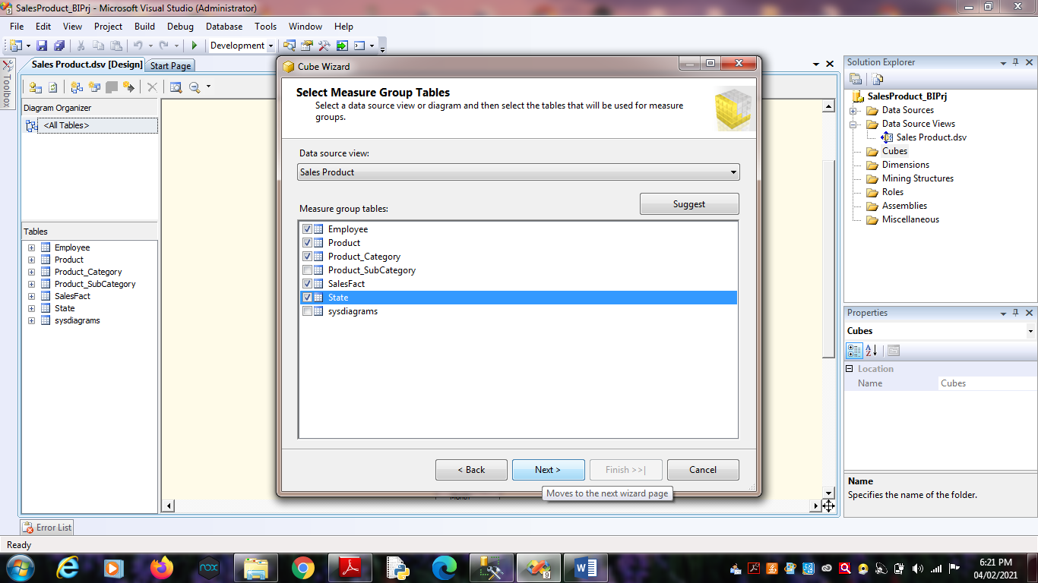

Click on Next.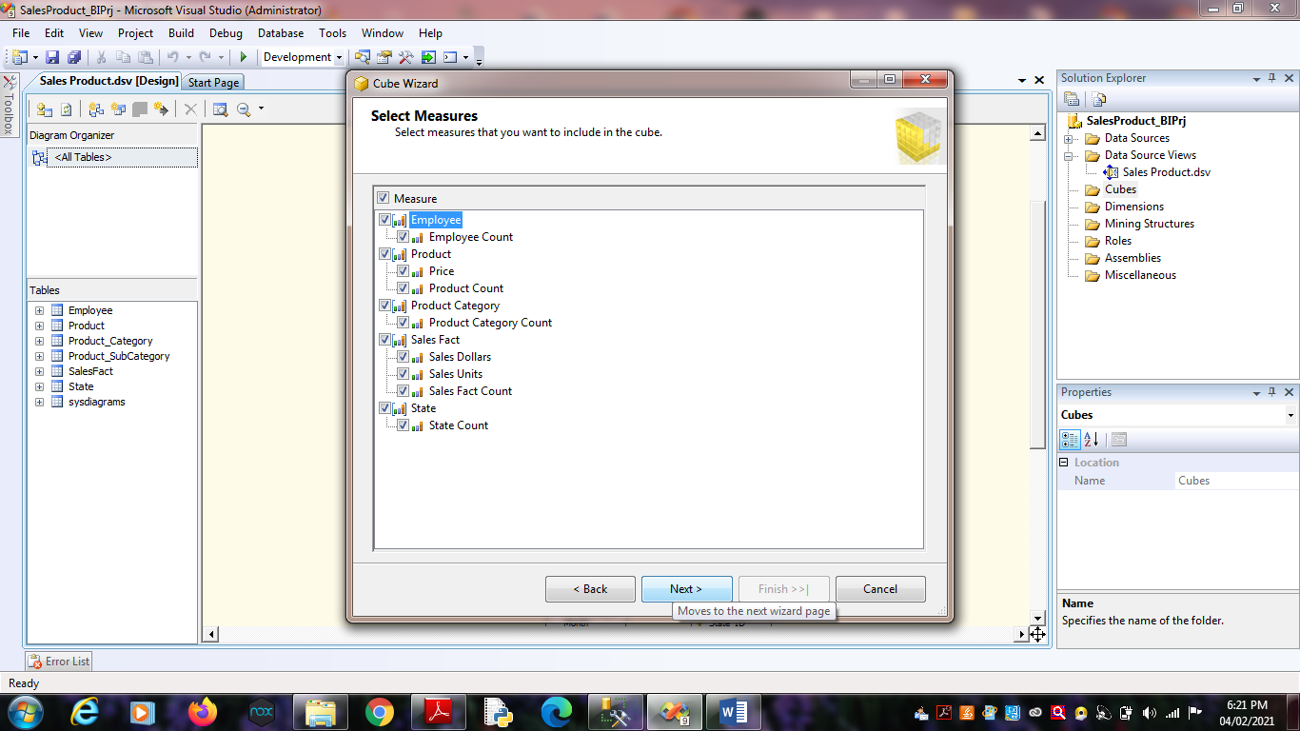 Click on Next.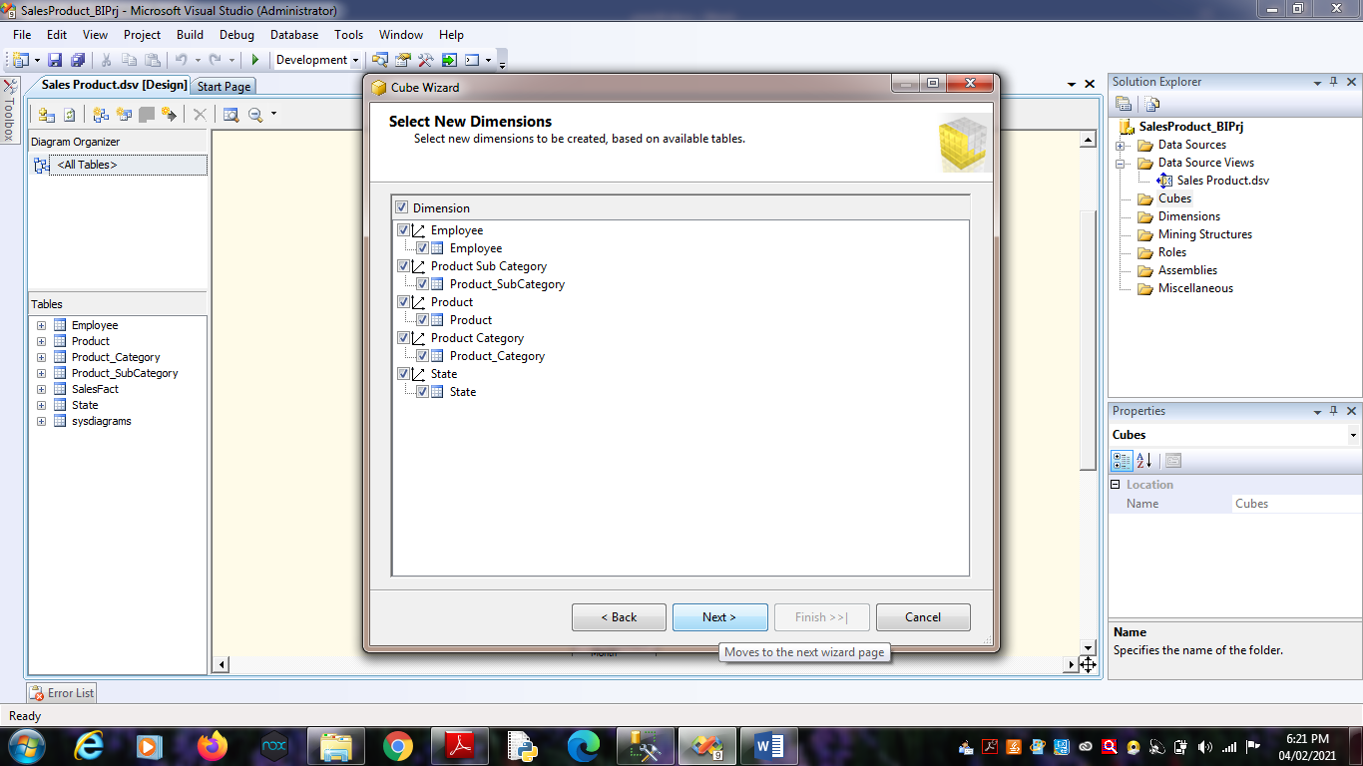 Click on Next.

4. Name Cube as “SalesCube”.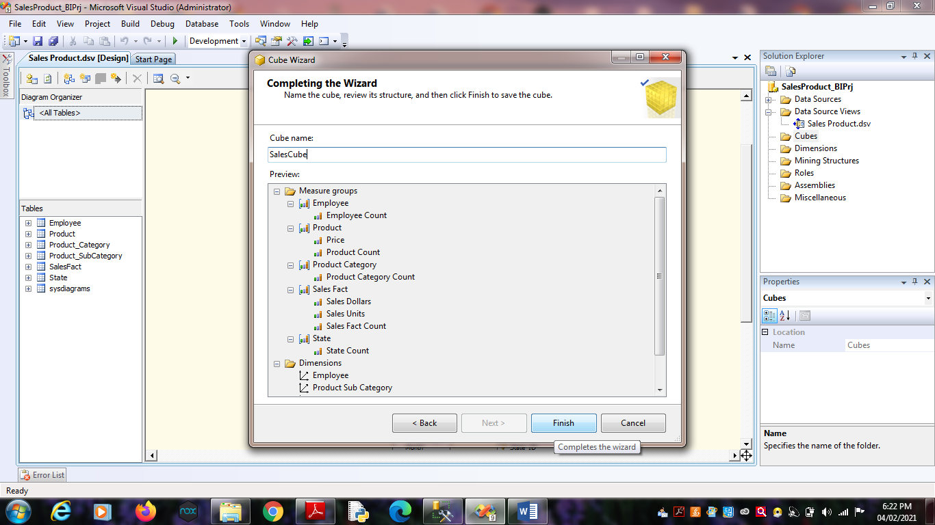

Click on Finish.

5. Finally, we will get the Cube View as well Dimensions View like :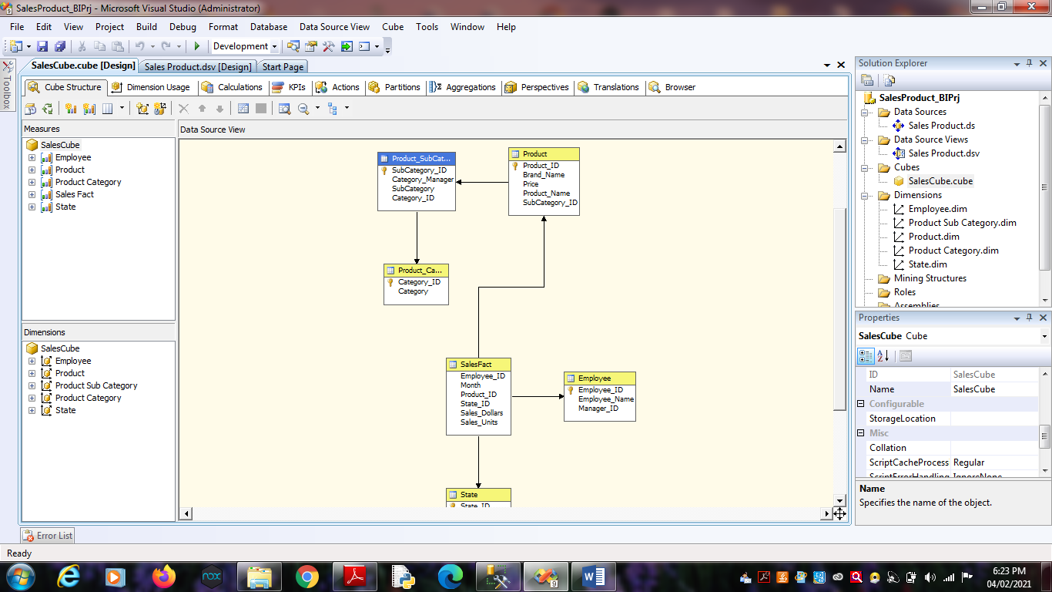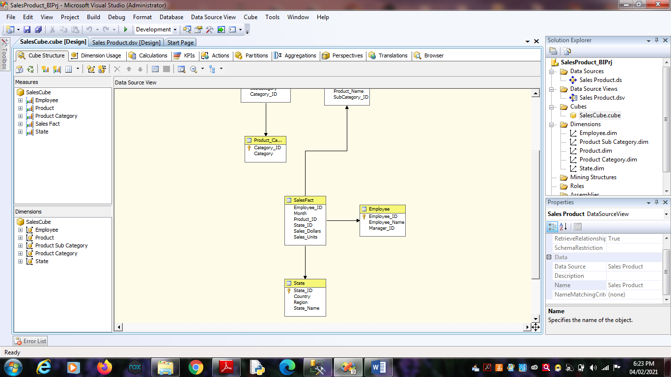

6. Finally, Process cube by Right click on SalesCube -> Process .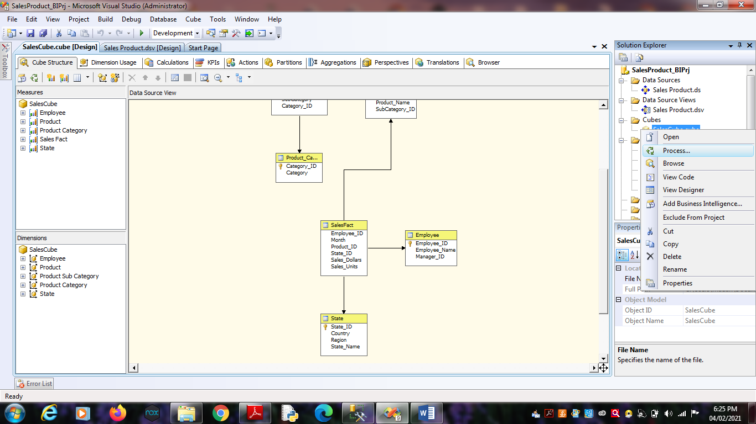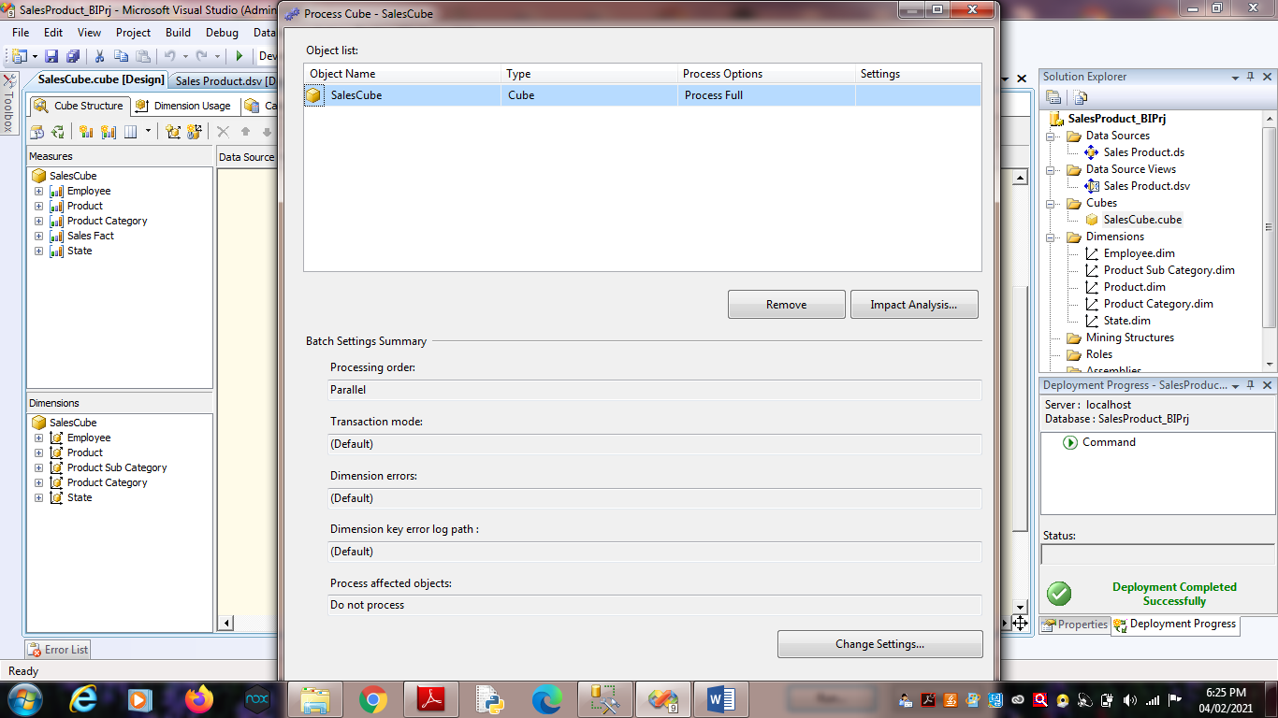

7. Click on Run.